**BOOTING PROCESS TROUBLESHOOTING**

**DATE – 10-12-2024**

**Condition - GRUB2 File crashed in BIOS System**

**## GRUB 2 Error Message-1**

**To demonstrate this, let’s remove the `grub.cfg` file from the system and restart it. If the `grub.cfg` file is missing or corrupted, the GRUB 2 boot loader will show the following error message.**

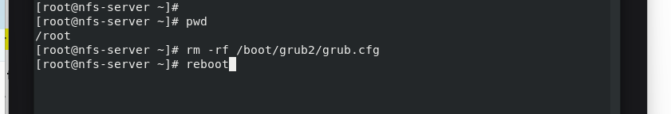

**Manually deleting the grub**

**```bash file**

**rm -rf /boot/grub2/grub.cfg**

**reboot**

**After the reboot, you will see the following error message.**

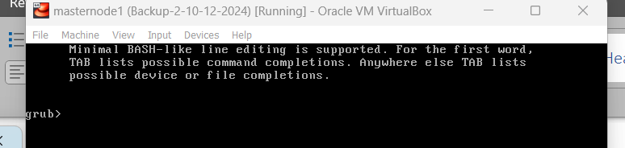

**Step 1 - How to Reinstall Corrupted GRUB 2 on RHEL 8, Rocky, CENTOS 9**

**To reinstall or recover the grub.cfg file or grub2 directory, you need to boot your system with the installation DVD/ISO image. On the boot screen of Red Hat 8, select the ‘Troubleshooting’ option and press Enter**

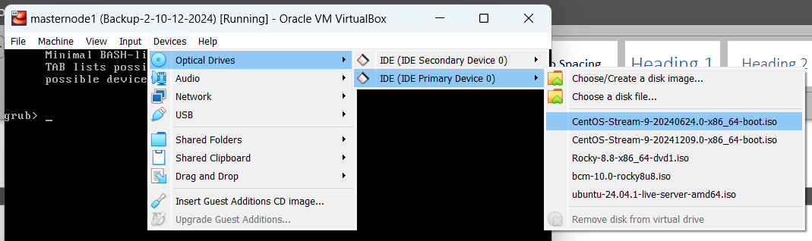

**Restart the Virtual machine (Master node1 )**

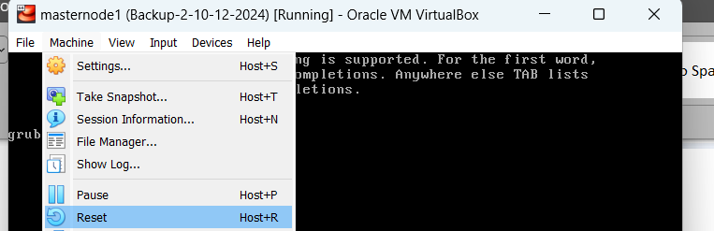

**Troubleshooting Screen appear on screen , Click the Troubleshooting option**

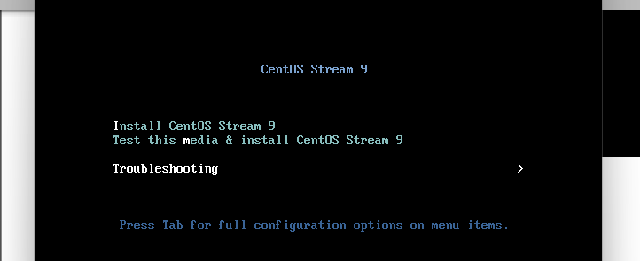

**SELECT OPTION – RESCUE OPTION – RESCUE A CENTOS STREAM SYSTEM**

**In the next screen, select the ‘Rescue a Red Hat Enterprise Linux system’ option and press Enter.**

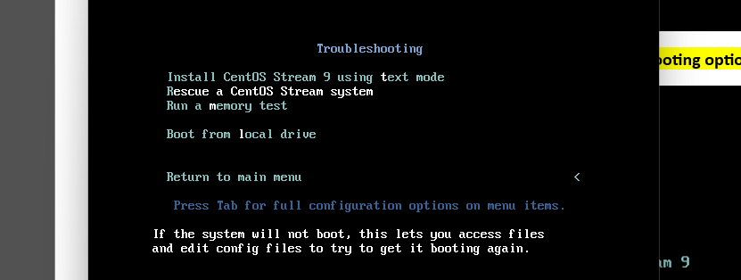

**Select Option - On the next screen, select option ‘1 (Continue)’ and hit ‘Enter’.** 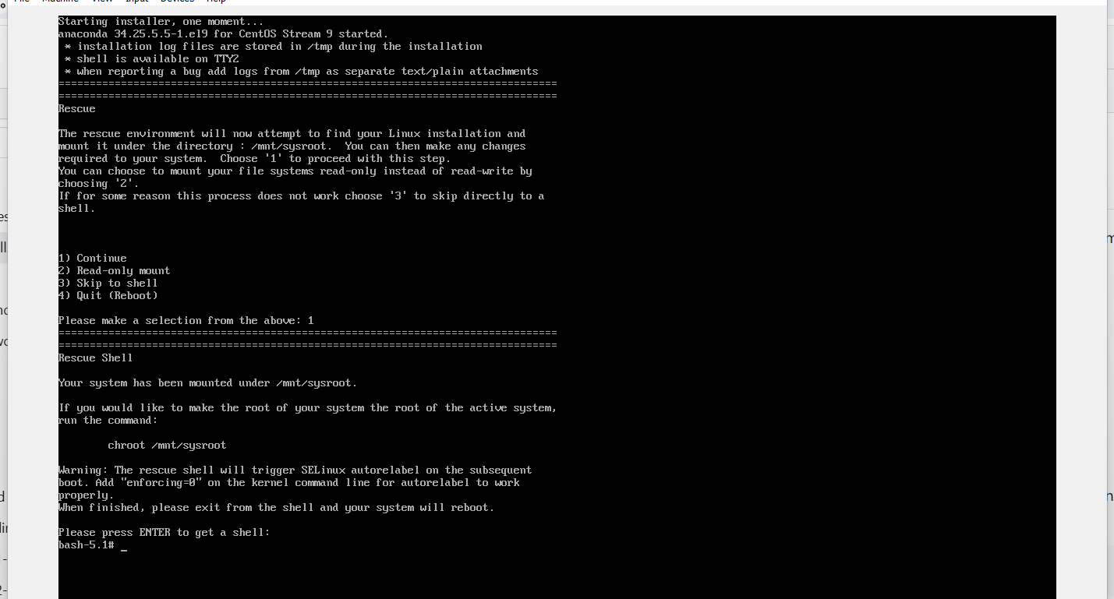

Run the below command

#mount

**See the last line , /mnt/sysroot/ (ro - read only ), we have to change as read write (rw) option**

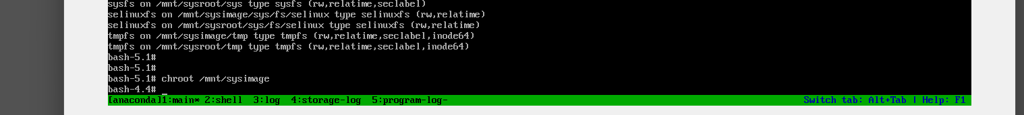

**# chroot /mnt/sysimage**

**Recovering the Corrupted GRUB 2 Bootloader -**

**Install GRUB2 in the primary hard disk, it would be /dev/sda. The grub-install command installs GRUB onto a given device, which includes copying GRUB images into the target directory (generally /boot/grub2).**

**# grub2-install /dev/sda**

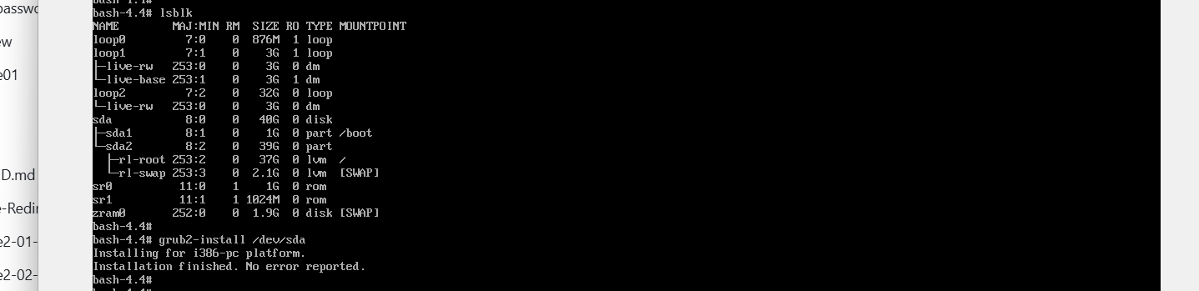

**Create a configuration file for GRUB2. The grub2-mkconfig command creates a new configuration file grub.cfg based on the current system configuration. This command uses the /etc/default/grub file and the customizable scripts in the directory /etc/grub.d/ when generating the grub.cfg file**

**#grub2-mkconfig -o /boot/grub2/grub.cfg or grub2.cfg**



**Enable the SELinux relabeling process on the next system boot:**

**# touch /.autorelabel**

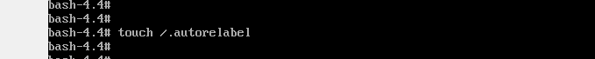

**Exit the chroot environment and reboot the system by executing the exit command twice:**

**#exit**

**Note: The system will automatically perform the relabeling process of all files, and the system will automatically restart when the relabeling process is complete.**

**Remove the Attached DVD or ISO file from Virtual Machine, So avoid the system to boot from attached ISO image**

**Then Reboot or Restart the VM, Below GRUB bootloaded image will load in Screen**

